DOI: XXXXXXXXXXXXXXXXXXXX - ISSN: XXXX-XXXX - Vol 1(1), 2020, pp: XX:XX
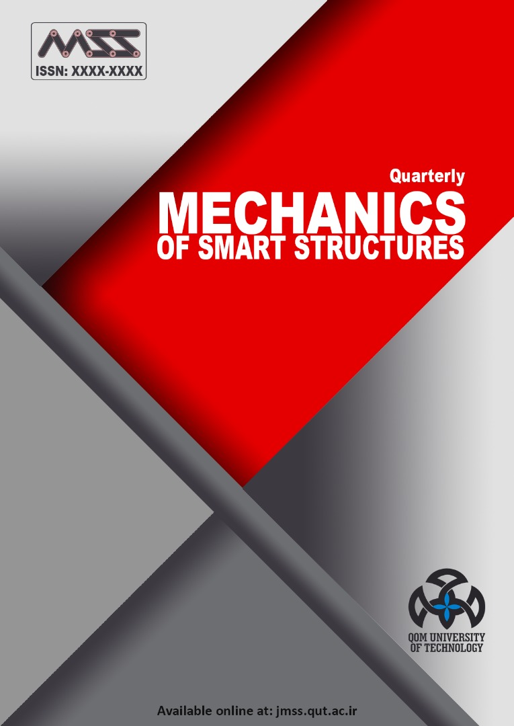 | Mechanics  Of Smart Structures  Available Online at: http://jmss.qut.ac.ir/ | 

Paper Title
ARTICLE INFO |  | Abstract
Article Type  Original Research |  | Abstracts contain most of the following kinds of information in brief form. The body of your paper will, of course, develop and explain these ideas much more fully. As you will see in the samples below, the proportion of your abstract that you devote to each kind of information—and the sequence of that information—will vary, depending on the nature and genre of the paper that you are summarizing in your abstract. And in some cases, some of this information is implied, rather than stated explicitly. The Publication Manual of the American Psychological Association, which is widely used in the social sciences, gives specific guidelines for what to include in the abstract for different kinds of papers—for empirical studies, literature reviews or meta-analyses, theoretical papers, methodological papers, and case studies. Your abstract should be intelligible on its own, without a reader’s having to read your entire paper. And in an abstract, you usually do not cite references—most of your abstract will describe what you have studied in your research and what you have found and what you argue in your paper. In the body of your paper, you will cite the specific literature that informs your research.
Authors
A. Someone¹
B. Someone^{2*}

Department of Mechanics, Qom University of Technology, Qom, Iran, someone@qut.ac.ir
2 Department of Physics, Qom University of Technology, Qom, Iran, someone@qut.ac.ir

* Correspondence
Address: Department of Mechanics, Qom University of Technology, Khodakaram Boulevard,
Qom, Iran. Postal Code: 71551313.
Phone: -
Fax: -
someone@qut.ac.ir
Article History
Received: March 16, 2020
Accepted: June 09, 2020
ePublished: September 20, 2020
 |  | Keywords: Keyword1; Keyword2; Keyword3; Keyword4.

Introduction
As you know, the hardest part is just to begin the paper. And what should do student at the beginning? Not writing an outline. And not working on the introduction. He should make a massive research on his topic. You cannot start writing an introduction without having a personal view on the issue that you are going to study. You have to prepare for introduction writing though analyzing facts available online and making notes. If it’s hard to do it yourself, the online essay help service will solve this problem instantly!
Research paper introduction is essential part of your writing and it must be created according to certain rules. It is true that when you write any kind of text you can push yourself too hard and cross borders of norms. Because academic styles of writing are referred to creative writing as well. You look for information, then analyze it, come up with thoughts, ideas, and reflect it in a coherent text. Next tips will show you how to fulfill the purpose of research paper introduction and get rid of the creative mess.
- Size matters. Before a tutor starts reading the article, he reviews it visually. If the size of introduction is too large, it will make a bad impression on your paper. Just remember, all you have to present in the introduction is: definition of the topic idea and its urgency, explanation of the aim of the research, facts to hook the reader and thesis statement.
- Be logical. Your introduction will be really strong if it contains key ideas only in few sentences. To reach such result it is important to satisfy logical connection of the thoughts. Your goal is to make reader understand in the end of the introduction what exactly you attempted to achieve in research paper and why this problem worth profound research.
- Make it the last part. Many successful students firstly work on the whole outline, write the body of the paper and only then form the introduction. That’s because a person becomes surer in what direction his research goes only after at least shallow search and analysis of sources.
- Review previous studies of your topic. Every person can study the same topic in a different way. Before you start your own research, you must become aware of the discoveries other scholars made on this issue. Any result will be a reliable background for the future work. Note that it is better to indicate recent developments in the primary research rather than a lengthy report.
At the end of this section, write the outline related to the rest of the paper.

Equation
To format your equation, use Equation Style, put a TAB before equation to align it as center, then put another TAB after equation to write equation number. If you want to number them automatically, use menu Reference>Insert-Caption>Equation. To cite the equations inside the text use menu Reference>Cross-reference. You can just copy and paste the Eq 1 and modify it.
$\int_{0}^{∞}{f\left(x\right).dx}$ Eq 1

Figures
Please use Figure and Figure Caption Style to put your figures. If you want to number them automatically, use menu Reference>Insert-Caption>Figure. To cite them inside the text use menu Reference>Cross-reference. For example: Based on Figure 1 the …
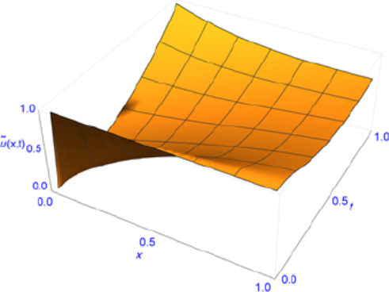
Figure 1: Variation of the

Tables
Please use Table and Table Caption Style to put your figures. If you want to number them automatically, use menu Reference>Insert-Caption>Figure. To cite them inside the text use menu Reference>Cross-reference. For example: Based on Table 1 the …
Table 1: Absolute errors
i | e_{i1} | e_{i2} | e_{i3}
1 | negligible | 3.22⨯10⁻¹⁴ | 3.22⨯10⁻¹⁴
2 | 3.22⨯10⁻¹⁴ | 3.22⨯10⁻¹⁴ | 3.22⨯10⁻¹⁴
3 | 3.22⨯10⁻¹⁴ | 3.22⨯10⁻¹⁴ | 3.22⨯10⁻¹⁴

Conclusion
Writing a conclusion for your research paper can be difficult. Concluding paragraphs should be clear and sum up what you have presented in your research without sounding redundant. An effective concluding paragraph can also add impact to what you have presented in your paper. In this article, you will learn the importance of writing a strong concluding paragraph, how to write one and some tips to help you write the conclusion for your research paper.

Acknowledgement
This research was supported/partially supported by [Name of Foundation, Grant maker, Donor]. We thank our colleagues from [Name of the supporting institution] who provided insight and expertise that greatly assisted the research, although they may not agree with all of the interpretations/conclusions of this paper.
Disclosure of Potential Conflicts of Interest
The Authors declare that there is no conflict of interest
Reference
- Joshi S, Prashant A, Deb A and Klain S. Analysis of buried pipelines subjected to reverse fault mo­tion. Soil Dynamics and Earthquake Engineering 2011 Jun1;124(11):980-3.

